**Secondary Snubber Design**

* Choose a resistor that allows proper damping.
* Choose a capacitor.
* Ensure there isn’t excessive power dissipation.

We measured Lleakage to be 2.84706µH.

“Two orders of magnitude between switching frequency and the snubber’s ringing frequency assumed for a good design”

Our aimed switching frequency was 50kHz, but due to the unavailability of the proper resistance values, it appears 44kHz in practice.

Therefore, a ringing frequency of 44MHz will be assumed.

The impedance of the leakage inductance: $Z=2πf_{ringing}L_{leakage}=78.709Ω$. This is taken directly as the snubber resistance.

Csnub used to minimize power dissipation at fsw and allow the resistor to be effective at fringing.

Power dissipation: $CV_{diode}^{2}f_{sw}$. Here, the article removes the 0.5 factor in the capacitor power equation, stating the capacitor charges and discharges continuously. Accordingly, P = 149mW.

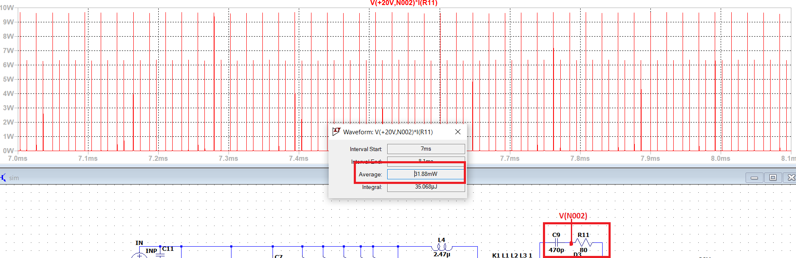

LTSpice displays a lesser power dissipation.